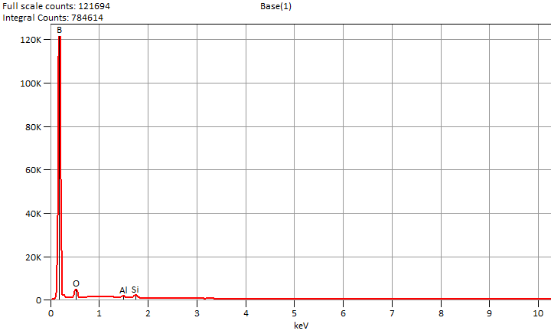

Live Time: 30.0 sec.

Wed Nov 27 14:16:06 2024

Filter Fit Chi Squared:582.144

Errors: +/- 1 Sigma

Correction Method: Proza (Phi-Rho-Z)

Acc.Voltage: 10.0 kV Take Off Angle: 45.8 deg.

Detector: UltraDry

WDS Results Unavailable for: Base(1)

|  |
| --- |
|  |

Quantitative Results for: Base(1)

|  |  |  |  |  |  |  |
| --- | --- | --- | --- | --- | --- | --- |
| ***Element***  ***Line*** | ***Int.***  ***Cps/nA*** | ***Int.***  ***Error*** | ***Weight %*** | ***Weight %***  ***Error*** | ***Atom %*** | ***Atom %***  ***Error*** |
| ***B K*** | 19024.3 | ± 165.8 | 89.5 | ± 0.8 | 93.4 | ± 0.8 |
| ***O K*** | 850.54 | ± 10.25 | 7.7 | ± 0.1 | 5.5 | ± 0.1 |
| ***Al K*** | 186.67 | ± 10.08 | 0.7 | ± 0.0 | 0.3 | ± 0.0 |
| ***Si K*** | 488.50 | ± 10.50 | 2.1 | ± 0.0 | 0.8 | ± 0.0 |
| ***Total*** |  |  | 100.0 |  | 100.0 |  |

ROI Results for: Base(1)

|  |  |  |
| --- | --- | --- |
| ***Operation*** | ***Gross Counts*** | ***Net Counts*** |

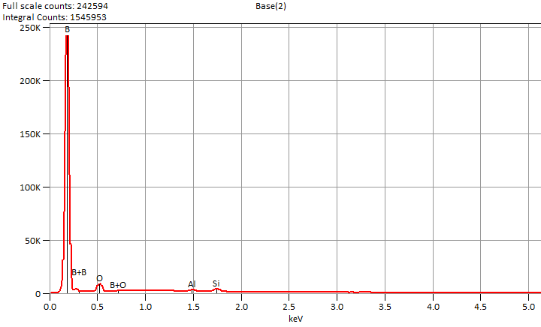

Live Time: 60.0 sec.

Wed Nov 27 14:18:38 2024

Filter Fit Chi Squared:1189.454

Errors: +/- 1 Sigma

Correction Method: Proza (Phi-Rho-Z)

Acc.Voltage: 10.0 kV Take Off Angle: 45.8 deg.

Detector: UltraDry

WDS Results Unavailable for: Base(2)

|  |
| --- |
|  |

Quantitative Results for: Base(2)

|  |  |  |  |  |  |  |
| --- | --- | --- | --- | --- | --- | --- |
| ***Element***  ***Line*** | ***Int.***  ***Cps/nA*** | ***Int.***  ***Error*** | ***Weight %*** | ***Weight %***  ***Error*** | ***Atom %*** | ***Atom %***  ***Error*** |
| ***B K*** | 18968.6 | ± 164.9 | 90.2 | ± 0.8 | 94.0 | ± 0.8 |
| ***O K*** | 745.52 | ± 7.38 | 6.9 | ± 0.1 | 4.9 | ± 0.0 |
| ***Al K*** | 206.31 | ± 7.17 | 0.8 | ± 0.0 | 0.3 | ± 0.0 |
| ***Si K*** | 484.13 | ± 7.50 | 2.1 | ± 0.0 | 0.8 | ± 0.0 |
| ***Total*** |  |  | 100.0 |  | 100.0 |  |

ROI Results for: Base(2)

|  |  |  |
| --- | --- | --- |
| ***Operation*** | ***Gross Counts*** | ***Net Counts*** |

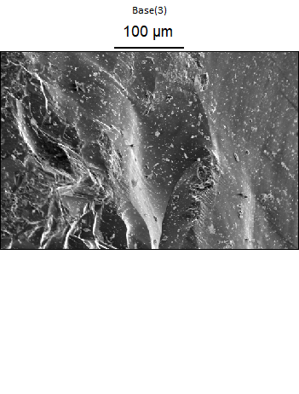

Data Type: Counts

Image Resolution: 512 by 340

Image Pixel Size: 0.83 µm

Map Resolution: 128 by 84

Map Pixel Size: 3.33 µm

Acc. Voltage: 10.0 kV

Magnification: 500

